Template: UOCAVA Reminder
Find this tool and links to related research on Center
for Civic Design’s website: civicdesign.org/tools/
uocava-email
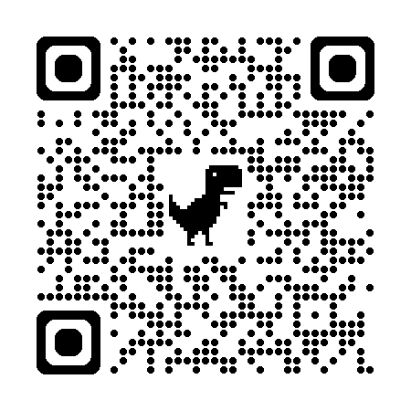
Use this template to write an email to your UOCAVA voters reminding them to complete the FPCA in advance. [Grey highlights] must be customized to your jurisdiction.
Subject line: Voting outside the US this year? Here’s what you need to do

Dear [First name],
Last election, you voted in [Jurisdiction name] from outside of the US. Do you want to again in 2026?
Here’s what you need to do:
- Complete the Federal Post Card Application (FPCA)
  - Find the form at fvap.gov
- Print it
- Sign it
- Return it as soon as possible so it reaches our office by the deadline
  - Upcoming deadlines:
    - Primary Election on [election date] – Apply by [insert]
    - General Election on [election date] – Apply by [insert]
  - How to return it:
    - Mail it to our election office [address or url to find it]
    - Email to [email]
    - Fax to [number]
You must fill out the FPCA for every election that you plan to vote by mail from outside of the US.

Who can use the FPCA?
You must be a military member, military family member, or an overseas citizen.
How will I know the office received my application?
Email us at [email]
When will I receive my ballot?
Ballots are mailed to military and overseas voters 45 days before the election.
More questions? Visit our UOCAVA page at [web address].

